

press release no. 2
(English translation)

THINK FUTURE: THREE DAYS OF EVENTS AND MEETINGS ON TOURISM

- The 61st edition of TTG Travel Experience stages nine Arenas with discussions and talks between leading figures in the tourism world. New frontiers and trends in hospitality, female leadership, neuroscience for the industry, climate change, inclusion and sustainability being the main themes

- Three days to upskill and learn about current events, innovation and trends that influence the industry

www.ttgexpo.it

Rimini, 9-11 October 2024 – Over 250 speakers will take the stage at the 9 Arenas and in the halls of Rimini Expo Centre for the 61st edition of TTG Travel Experience, organised by Italian Exhibition Group (9-11 October 2024).
For three days, the expo centre will be the epicentre of tourism where industry professionals will be briefed on the latest trends, innovations and travel opportunities on this major platform for networking and updates. Thanks to the Think Future programme, tourism companies will have the opportunity to meet with experts, academies, economists, sociologists and creative figures to redesign products and maps capable of intercepting new trends. The topics covered are transversal to the entire tourism industry: from current emergencies that require new interventions in the industry to environmental issues, from the world of work to female leadership, from the promotion of destinations to the new frontiers of hospitality, right up to cutting-edge solutions for the creation of new tourism products that include AI.
With more than 200 events in the Think Future programme, an overview of future market and traveller trends in 2024 will be provided by the presentation of “In dato VERITAS”, the analysis of the Travel Innovation Observatory of the Polytechnic University of Milan. As every year, Travel&Hospitality Vision +25 by TTG will also be presented, with the socio-semiotic survey of the indicators that will guide the choices of the tourism market over the next 3 years.
Bridging the gap created by gender stereotypes that prevent women from establishing themselves in the industry will be discussed during the event: "Tourism Dream Gap": the truth about female leadership in tourism companies. Case histories and ideas for improvement for all generations". The search for "Veritas", the main theme of the 2024 edition of TTG, is also reflected in the world of work, opening up a discussion for young people who want to work in tourism. The debate “The truth about Millennials and Gen Z: young managers speak out. A meeting of minds between those offering and those looking for work” will try to unravel the knots on the topic by addressing the critical issues that arise from the meeting between supply and demand.
On the Hospitality front, the talk “Total Outdoor: recreating what’s real. Open-air hospitality figures and the new balances between aquatic, natural and indoor environments” will feature major representatives of Federalberghi and Faita-Federcamping, addressing the challenge of companies are facing in the new design of outdoor spaces to satisfy the demand of tourists looking for increasingly less artificial outdoor environments and closer contact with nature.
The hotel system is also facing a new phenomenon linked to sleep tourism and the search for new rest practices in the facilities. With the collaboration of the Sleep Medicine Centre of the San Raffaele Hospital – Milan and Aipef, new food for thought will arise in the talk “The quality of sleep, the quality of dreaming. Sleep disorders: the scientific truth to improve the guests’ sleep”.

Moving on to a rapidly growing sector such as luxury tourism, Deloitte will illustrate a data analysis bringing to light the most recent truths on the situation in “Luxury Hospitality: emerging markets, investments and trends. Present and future of the sector in Deloitte statistics”.
Several events will address the topic of climate change and its impact on tourism, including “Tourism Objective 2035: the moment of truth and new challenges. Climate, migration and adaptation strategies” chaired by Carlo Sangalli, president of Confcommercio-Imprese for Italy, and featuring other institutional representatives. Other factors such as stability, the security of national economies and the planet’s climate structure will be discussed on a time horizon projected to 2030 and 2035, analysing the possible actions that companies and professionals will have to undertake.
The evolution of the beach concession system, at the centre of the current public debate, will be addressed from different points of view that also touch on the digitalization of beaches. A regional focus takes a deep dive into the 2024 summer season, the differences between Italian and foreign tourists and the progress recorded to date. All this in the talk curated by the Spiagge.it portal, entitled “Smart beaches: where is the industry at? The truth about the 2024 season in the figures by the Spiagge.it National Observatory”.

ABOUT: TTG TRAVEL EXPERIENCE
Event: international trade show; organizer: Italian Exhibition Group SpA; recurrence: annual; edition: 61st; open to: reserved exclusively for trade professionals; website: www.ttgexpo.it - #ttgexpo

ABOUT: INOUT | THE CONTRACT COMMUNITY
Event: international trade show; organizer: Italian Exhibition Group SpA; recurrence: annual; edition: 2nd edition of INOUT including SIA, SUN, SUPERFACES, GREENSCAPE; open to: reserved exclusively for trade professionals; website: www.inoutexpo.it #inoutexpo

PRESS CONTACT IEG, TTG TRAVEL EXPERIENCE
Elisabetta Vitali, head of corporate communication & media relation; Marco Forcellini, Pier Francesco Bellini, press office manager - media@iegexpo.it

MEDIA AGENCY TTG TRAVEL EXPERIENCE: Mind The Pop
Martina Vacca: martina@mindthepop.it, mob. +39 339 748 4994; Fabrizio Raimondi: fabrizio@mindthepop.it, mob. +39 335 389 848; Benedetto Colli: benedetto@mindthepop.it, mob. 380 371 2272; Stefano Chiossi: stefano@mindthepop.it, mob. + 39 388 739 4358.

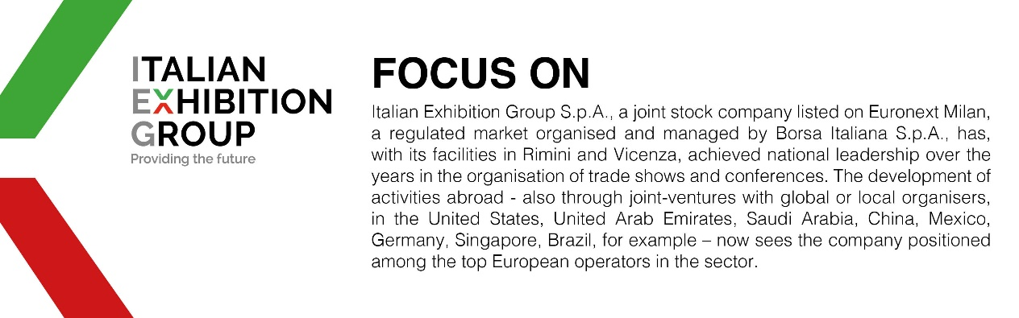

This press release contains forecast elements and estimates that reflect the management’s current opinions (“forward-looking statements”), particularly regarding future management performance, realization of investments, cash flow trends and the evolution of the financial structure. For their very nature, forward-looking statements have a component of risk and uncertainty, as they depend on the occurrence of future events. The effective results may differ (even significantly) from those announced, due to numerous factors, including, only by way of example: food service market and tourist flow trends in Italy, gold and jewellery market trends, green economy market trends; the evolution of raw material prices; general macroeconomic conditions; geopolitical factors and evolutions in the legislative framework. Moreover, the information contained in this release does not claim to be complete, and has not been verified by independent third parties. Forecasts, estimates and objectives contained herein are based on the information available to the Company as at the date of this release.

